ISRAEL AND PALESTINE - UNDERSTAND THE CONFLICT SEE THE FILM:
"WITH GOD ON OUR SIDE''
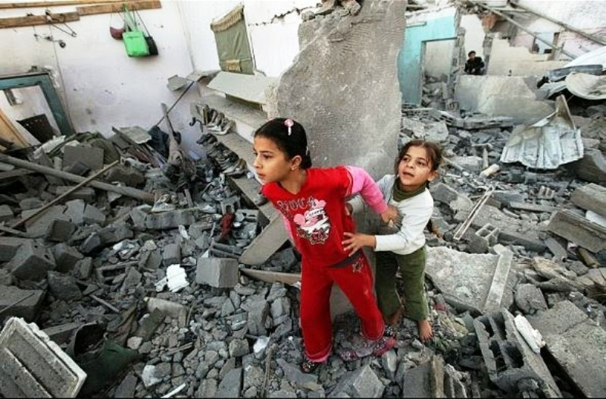

A documentary that explains the huge influence of Christian Zionism and answers that view.
This film is also an enlightening history of the establishment and expansion of Israel and a plea for human rights and peace to prevail.
Screening at Avalon Baptist Peace Memorial Church
Date: Sunday -28th JUNE 10 am - 12 noon
Place: Avalon Baptist Church : 2 George St. Avalon (free entry free morning tea)
Voluntary Donations: Nepal (World Vision)
info: Kath Moody 99971815
