Safe Church Concerns Form
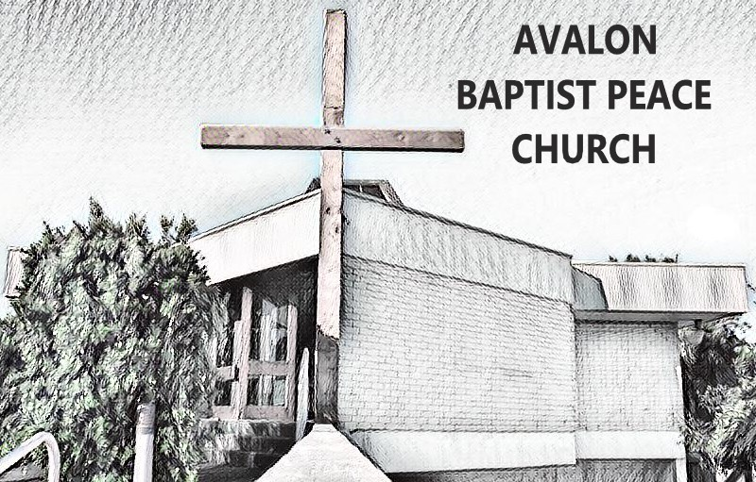
The completed form should be given to a member of your Safe Church Team who will follow the Procedure for Responding to Child Protection Concerns.
This documentation is to be kept in a locked filing cabinet and/or in secure electronic format for at least 45 years (preferably 100 years) from the date of completion.
Please do not discuss the concern with anyone other than the Safe Church Team or your Ministry Team Leader.

If there is immediate danger please contact police immediately.

Church Name: ____________________________

DETAILS ABOUT PERSON COMPLETING THIS FORM
(either the victim, the person bringing a concern, or the safe church team)
Name:
Role:
Relationship to the victim and/or the person allegedly causing harm:
Address:

Email
Phone:
DETAILS OF ALLEGED VICTIM (if applicable)
Name:
Date of Birth: Age: | Gender:
Address:

Parent/guardian name and contact phone number:
DETAILS OF THE PERSON AGAINST WHOM THE ALLEGATION HAS BEEN MADE (if applicable)
Name
Date of birth if known otherwise approximate age:
Home address:
Email
Phone:

Position/title at time of allegation (if any):
Is the person aware of the existence of the allegations? Yes / No

NATURE OF THE ALLEGATION
Provide details of the allegations that were made known to you – what has been alleged, when it was alleged to have occurred, other relevant details (if necessary use additional page/s and attach to this form).

Are there additional pages attached to this form? Yes / No Number of pages:
Names and contact details of any witness/es:

Have written accounts from witnesses been attached? Yes No If yes, number of pages
(written accounts should be received from each person who received a disclosure or observed a concern, however, do not start an investigation at this stage)
- Who else knows about the alleged abuse?
Signature (of person bringing concern): | Date:
Part two - Safe Church Team to complete the following information
In NSW, Mandatory Reporter Guide completed? Yes / No
If yes, please attach report printout
Other government agencies or departments involved:
Agency | Date | Reference/Event Number | Name of contact
Police
DCJ (FaCS)/ CYPS
OCG/Ombudsman

Contact with Ministry Standards Hotline 1300 647 780
Date and time:
Emailed copy of Safe Church Concerns Form to standards@nswactbaptists.org.au
Date and time:
Safe Church Team provides feedback to the person bringing the concern about church response and any reports made. (include tick box and date and time) : Yes / No
Signature of Safe Church Team Member | Date:

