Safe Ministry Screening Questionnaire
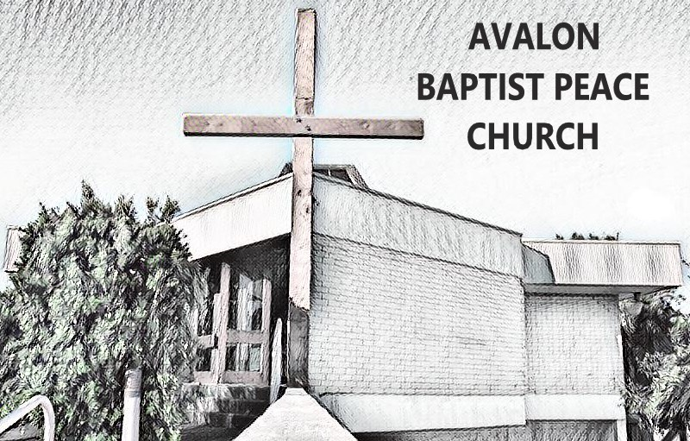
For staff and volunteers aged 18 and over
Please Note: This is a sensitive document that must be stored in a confidential manner accessible only by a limited number of authorised persons.

PERSONAL DETAILS
Surname: ...............................................................................................................................
Given Names:.........................................................................................................................
Previous Name/s (if applicable):.............................................................................................
Date of Birth: .............../............/.............................. Male/Female .......................
Address: ................................................................................................................................
Phone: .............................................................Email: ..........................................................
WWCC / WWVP Number (if required): ................................................................................
Please outline any health conditions that may affect your volunteer role?
................................................................................................................................................
................................................................................................................................................

Please circle either “YES” or “NO” for each of the following questions. If you answer “yes” to any of the following questions, please give details on a separate page or discuss with the Senior Pastor or the person holding an equivalent leadership role in your church. A ‘yes’ answer will not automatically rule an applicant out of selection.

Please note that, if you disclose any potentially criminal actions, the church may need to report this information to the police or other relevant government authorities.

For all staff and volunteers
- Have you ever been charged with or convicted of a criminal offence? | Yes / No
- As an adult (18+ years) have you ever engaged in any of the following conduct:
- sexual contact with someone under your care other than your spouse (such as a parishioner, client, patient, student, employee or subordinate) | Yes / No
- use, possession, production or distribution of child abuse material? | Yes / No
- sexual contact with a person under the relevant age of consent | Yes / No
- To your knowledge, has there ever been any allegations made against you regarding any abuse of a child, physical abuse or sexual misconduct? | Yes / No
- Have you ever had an apprehended violence order, order for protection or the like issued against you as a result of allegations of violence, abuse, likely harm, harassment, stalking, etc? | Yes / No
- Have you had a history of alcohol abuse or substance abuse (including prescription, over-the-counter, recreational or illegal drugs)? | Yes / No
- (if the ministry role may involve driving) Has your driver’s licence ever been revoked or suspended? | Yes / No
For staff and volunteers in pastoral ministry, leadership or engaged in child-related work or work with vulnerable adults
- Have you ever had permission to undertake paid or voluntary work with children or other vulnerable people refused, suspended or withdrawn in Australia or any other country? | Yes / No
- Has a child or dependent young person in your care ever been removed from your care by relevant authorities? | Yes / No

CHURCHES YOU HAVE ATTENDED REGULARLY IN THE PAST 3 YEARS

Name of church | Location | When (Month/Year) | Any positions held

REFEREES
Please provide details of two referees who are over eighteen years of age and able to give a verbal report on your character and suitability for ministry. Referees may be part of the Church.
Referee 1
Name: ............................................................... Phone: ..........................................................
Referee 2
Name: .............................................................. Phone: ..........................................................

WORKING WITH CHILDREN CHECK AND/OR NATIONAL POLICE CHECK
I consent to * verification of my WWCC number (in NSW, if required)
* a National Police Check (for staff only)
CONSENT TO HOLD INFORMATION
I consent to the information contained in this application, including any subsequent pages, to be kept by our Church. I understand that this information will be kept in a confidential file and used only for screening purposes.
DECLARATION
I,.................................................................................. sincerely declare that:
- The information I have provided in this application is true and correct to the best of my knowledge and belief.
- I understand that if I provide false or misleading information or withhold relevant information from this questionnaire, the church leadership may determine that I am unsuitable to serve in any role in the Church.
- I have received a copy of the Code of Conduct and am willing to uphold it.

Applicant’s signature: .............................................................................Date: ........................
Church Use Only
CSS Training undertaken: (date of training) __________________
WWCC/WWVP No. supplied Yes / NA Expiry date ___________________
(if in NSW) WWCC Verified by:(name) _________________________ On (date):________
Signed Code of Conduct received by: (name) _____________________ On (date):________
Entered onto Safe Church Register by: (name) _____________________ On (date):________
Interview led by: (name) ____________________________________ On (date):________
Referee Checks conducted by: (name) _______________________ On (date):________
Volunteer Endorsement* by (name) _______________________ _ On (date):________
Induction led by (name) _____________________________________ On (date):________
*Volunteers must be endorsed by a member of pastoral staff, governance group or safe church team
. Full records of the above processes (including interview notes, referee check comments and induction content) should be kept in the relevant individual’s personnel file.


Safe Ministry Screening Questionnaire
Insert Church Logo Here
For anyone aged under 18 serving as a volunteer or a junior volunteer/helper.

This is a sensitive document that must be stored in a confidential manner accessible only by a limited number of authorised persons.

PERSONAL DETAILS
Surname: ...............................................................................................................................
Given Names:.........................................................................................................................
Previous Names (if applicable) ..............................................................................................
Date of Birth: ........./............/.............. Male/Female: ..............................................
Phone/s: ...................................................... .........................................................................
Address: ................................................................................................................................
Email: ....................................................................................................................................
Please outline any health conditions that may impact your volunteer role?
................................................................................................................................................
................................................................................................................................................

Name of at least one Parent/Guardian: ………......................................................................
Contact Phone for Parent/Guardian: .....................................................................................

Please circle either “YES” or “NO” for each of the following questions. If the answer to any of the following questions is “yes”, please give details on a separate page or discuss with the Senior Pastor or the person holding an equivalent leadership role in your church.

A ‘yes’ answer will not automatically rule an applicant out of selection.
Please note that, if you disclose any potentially criminal actions, the church may need to report this information to the police or other relevant government authorities.

- Have you ever been charged with or convicted of a criminal offence? |  | Yes / No
- Have you a history of alcohol abuse or a history of substance abuse including prescription, over-the-counter, recreational or illegal drugs? |  | Yes / No
- To your knowledge, has there ever been any allegations made against you regarding any abuse of a child, physical abuse or sexual misconduct? | Yes / No

CHURCHES YOU HAVE ATTENDED REGULARLY IN THE PAST 3 YEARS

Name of church | Location | When (Month/Year) | Any positions held

REFEREES
Please provide details of two referees who are over eighteen years of age and able to give a verbal report on your character and suitability for ministry. Referees may be part of the Church.
Referee 1
Name: ...............................................................Phone: ..........................................................
Referee 2
Name: ..............................................................Phone: ..........................................................

CONSENT TO HOLD INFORMATION
I consent to the information contained in this application, including any subsequent pages, to be kept by our Church. I understand that this information will be kept in a confidential file and used only for screening purposes.

DECLARATION
I,.................................................................................. sincerely declare that:
- The information I have provided in this application is true and correct to the best of my knowledge and belief.
- I understand that if I provide false or misleading information or withhold relevant information from this questionnaire, the church leadership may determine that I am unsuitable to serve in any role in the church.
- I have received a copy of the Code of Conduct and am willing to uphold it.

Applicant’s signature: .............................................................................Date: ........................

PARENT GUARDIAN SIGNATURE
Name of parent/guardian: ...................................................................................................
Signature: ..................................................................................................Date:.....................
Church Use Only
Parental Consent obtained (name): __________________________ On (date): _______
WWVP number (16/17 yo in ACT)___________________________ On (date): _______
CSS Training undertaken (for 16/17 yo in non-junior roles): On (date): _______
Interview led by: (name) ___________________________________ On (date):________
Referee Checks conducted by: (name) _______________________ On (date):________
Senior Leadership Endorsement (name) ______________________ On (date):________
Entered onto Safe Church Register: (name) ____________________ On (date):________
Induction led by (name) ___________________________________ On (date):________

*Volunteers must be endorsed by a member of pastoral staff, governance group or Safe Church Team

Full records of the above processes (including interview notes, referee checks and induction content) should be kept in the relevant individual’s personnel file.

