Ministry Information Form
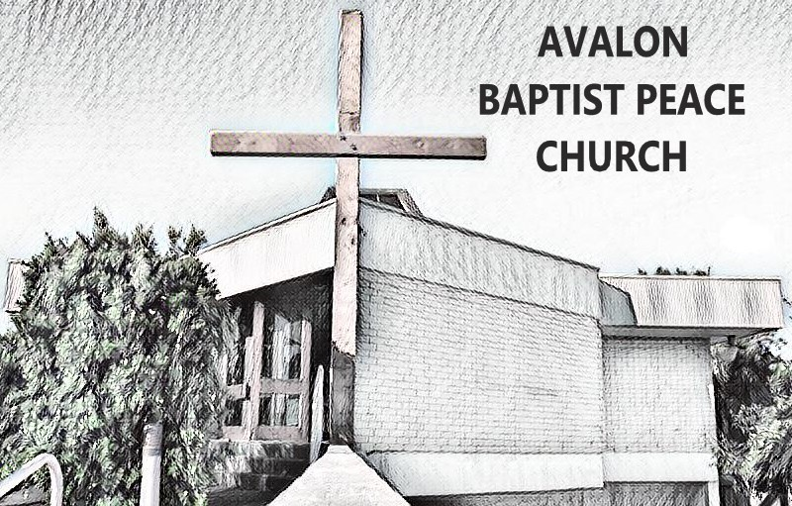
Church name: Avalon Baptist Peace Church
Program name:

GENERAL INFORMATION
Participant’s name: ________________________ Date of birth: _______________
Parent/guardian name/s: __________________________________________________
Phone: _______________________________ Email: _____________________________

Dietary issues: Is there anything your child can not eat and/or drink? Yes / No
(If yes, please indicate foods or beverages your child should not consume.)
________________________________________________________________________________________________________________________________________________________________________________________________________________________

Medical conditions: Please list any medical conditions or allergies, and any medication or special care they require. If your child is anaphylactic to any substance, please provide information regarding EpiPen and management plan.
________________________________________________________________________________________________________________________________________________________________________________________________________________________

IN CASE OF EMERGENCY
Emergency Contact 1 Name: _____________________________________________
Relationship to child: _____________________________________________
Phone: (h)(w)(m): _____________________________________________
Emergency contact 2: Name: _____________________________________________
Relationship to child: _____________________________________________
Phone: (h)(w)(m): _____________________________________________
I authorise the leader in charge to arrange for my child to receive such first aid and medical treatment as a trained first aid person may deem necessary.
I authorise the use of calling an ambulance in an emergency.
I accept responsibility for payment of all expenses associated with such treatment.
Please read the follow statement and tick the boxes from which you wish to preclude your children:
I DO NOT give permission for my child to participate in activities outside of the normal meeting complex except where they are within reasonable walking distance.
I DO NOT give permission for my child to be transported in private cars arranged by the leaders of the group.
I DO NOT permit photos taken of my child to be displayed in Church publications, e.g., website, newsletters, brochures, etc.
Transport authority: If I am unable to collect my child at the finishing time, they may be transported home from the program with the following people: _____________________________________________________________________________

Signature of parent/guardian: ________________________________________________
Name: _______________________________________ Date: __________________

