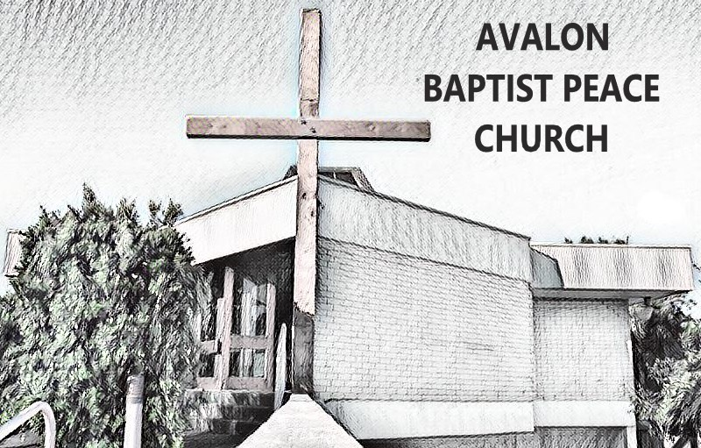

Safe Church Team Role Description

Adopted by [governance body] on [date]

A person appointed as a Safe Church Team Member should be a mature Christian who has been recruited according to the Procedure for Staff and Volunteers, have a current WWCC / WWVP clearance and have attended a Creating Safe Spaces workshop in the last 4 years. Close and direct liaison with the Senior Pastor / Senior leader and an ability to maintain confidentiality is essential.

The responsibilities of the Safe Church Team include:

- to provide oversight of the church’s Safe Church program, including Safe Church Policy and procedures.
- to provide oversight of the management of Safe Church/Child Protection concerns/reports.

Specific Roles:

1. Oversight of the Safe Church Policy and Procedures
- Preparing Safe Church Policy and Procedures for the church in line with legal responsibilities and Baptist Churches of NSW & ACT recommendations.
- Implementing the Safe Church Policy and procedures, including:
  - Promoting awareness of and adherence to the Safe Church Policy and procedures (including ensuring that staff and volunteers have completed National Police Checks, WWCC/WWVP clearances and Creating Safe Spaces training).
  - Maintaining records related to Safe Church Policy and procedures.
- Preparing regular reports for Deacons /Elders/Church leadership meetings.
- Reviewing Safe Church Policy and procedures annually or more often if required due to changing legislation.
- Receiving feedback from Church leaders, children, families and communities regarding Safe Church Policy and procedures.
- Overseeing the completion of the ‘Safe Church Health Check’ every 3 years.
2. Management of Safe Church/Child Protection Concerns and Incidents
- Receiving reports of child protection concerns from church staff, volunteers, ministry leaders and/or Church members.
- Providing support in following the procedure for responding to child protection concerns and incidents.
- Contacting the Baptist Churches of NSW & ACT Ministry Standards Manager to discuss action plan/appropriate action.
- Making any reporting calls (to Police, Government authorities) as required.
- Ensuring reporting in line with relevant Reportable Conduct Legislation.
- Ensuring child protection concerns and subsequent responses have been appropriately documented.
- Ensuring adequate follow-up and pastoral care of all persons involved in a child protection concern/incident.
- Assisting with legal, procedural and risk management issues related to a child protection concern/incident.
- Keeping records, filing complaints and reports of investigations in a secure file, in accordance with the record-keeping procedure.

