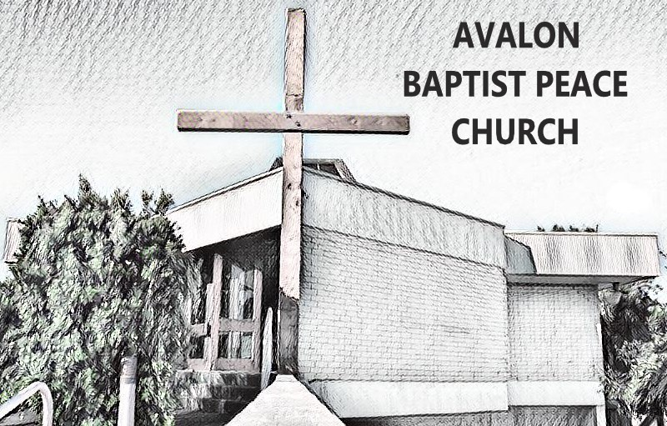

Model Work Health and Safety Team Role Description

Adopted by [governance body] on [date]

To fulfil their duty of care, we recommend that each local church appoint a Workplace Health and Safety (WHS) Team (ideally between 2-4 people). Each member of the WHS team and all paid pastoral staff should complete WHS training.

WHS teams should undertake the free online WHS training offered by Baptist Insurance Services and are encouraged to make use of the many other resources provided by Baptist Insurance Services on their website to assist local churches in general risk management and church specific risk management.
The responsibility of the Work Health and Safety Team includes:

- To provide oversight of the church’s Work Health and Safety program, including policy and procedures

Specific Roles:

  - Develop and implement appropriate WHS policy and procedures including the following:
  - Evacuation and Emergency responses.
  - Safe Manual Handling, Visual and Auditory Care.
  - Risk Assessments.
- Address health and safety concerns within one month of the concern being raised.
- Report to senior leadership team meetings regarding work health and safety and provide reports as appropriate.
- Ensure Risk Assessments are completed for all church ministry programs (both onsite and offsite).
- Ensure incident report documents are completed and stored, and that serious or dangerous incidents are notified to Baptist Insurance Services (or relevant insurer) as required.
- Undertake a safe environment audit of the church site a least once a year, or more regularly for high-risk areas, ensuring that any concerns are appropriately rectified.
- Any other tasks as advised in the Baptist Insurance Services Risk Management Guide for Churches.

